**PROJECT DESIGN PHASE-II DATA FLOW DIAGRAM AND USER STORIES :-**

|  |  |
| --- | --- |
| Team ID | PNT2022TMID33026 |
| Project Name | Project – IOT BASED SAFETY GADGET FOR  CHILD SAFETY AND NOTIFICATION SYSTEM |

|  |  |  |  |  |  |  |
| --- | --- | --- | --- | --- | --- | --- |
| **User Type** | **Functional**  **Requirement (Epic)** | **User Story Number** | **User Story / Task** | **Acceptance criteria** | **Priority** | **Release** |
| Customer (Mobile user) and (Web  user) | Registration | USN-1 | As a user, I can register my account by entering my email, password, and confirming my password. | I can access my account  / dashboard | High | Sprint-1 |
|  |  | USN-2 | As a user, I will receive confirmation email once I have registered myself | I can receive confirmation email & click confirm | High | Sprint-1 |
|  |  | USN-3 | As a user, I can register for the application through apple account | I can register & access  the dashboard with apple account Login | High | Sprint-2 |
|  | Login | USN-4 | As a user, I can log into the application by entering user id & password |  | High | Sprint-1 |
|  |  |  |  |  |  |  |
|  |  |  |  |  |  |  |
| Customer Care Executive | Login |  | As I enter I can view the working of the application and scan for any glitches and  monitor the operation and check if all the users are authorized. | I can login only with my provided credentials | Medium | Sprint - 3 |
| Administrator | Login |  | Maintaining and making sure the database containing the locations are secure and accurate and updated constantly. | I can login only with my provided credentials | High | Sprint - 3 |

DATA FLOW DIAGRAM

Current location with a warning

Log in credentials

Position w/iLh respect to the geDhznce

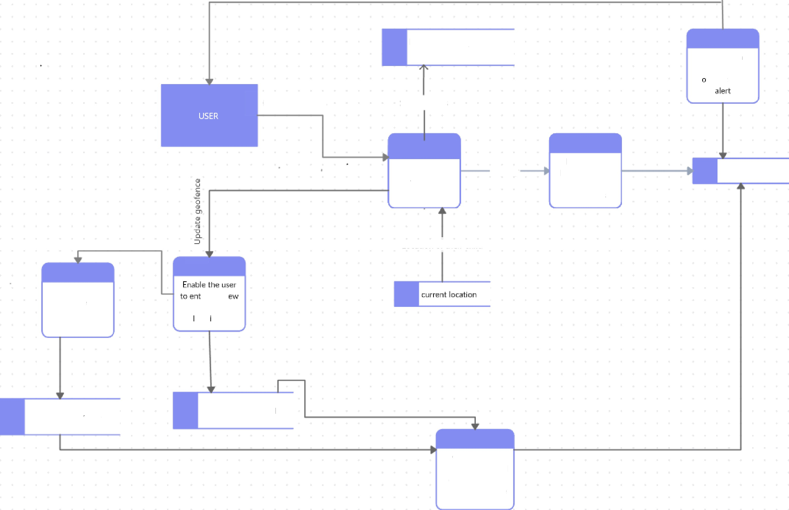Safety status

Check with geofence , if out f to range

Own Der account

I nrat inn nf th eir r hiI+4

History

Display the location of the child with timestamps

Recent Ic›catIon

Input the safety range

safety distance iange

er the n

geofence

QCdt OFi9

Geofence of tll+ child

Compute the safety range based on the recently updated geofence